bannerr_rmx.gif

DIS Conversion Tool User Guide

[Overview 2](#_Toc334698025)

[Working with the DIS Conversion Tool 3](#_Toc334698026)

[To Open the DIS Conversion Tool 3](#_Toc334698027)

[To Specify Files 3](#_Toc334698028)

[To Halt Processing 4](#_Toc334698029)

[To Execute the DIS Conversion Tool 5](#_Toc334698030)

[To Clear Tables 6](#_Toc334698031)

[To Clear the Process Log 8](#_Toc334698032)

[To View the Process Log 8](#_Toc334698033)

[To Stop Processing on a Current Conversion 8](#_Toc334698034)

[To Exit the Application 10](#_Toc334698035)

[Working with the Command Line 11](#_Toc334698036)

[To Open the Command Prompt 11](#_Toc334698037)

[Command Line Arguments 12](#_Toc334698038)

[To Execute the DIS Conversion Tool using the Command Line 12](#_Toc334698039)

# Overview

The DIS Conversion Tool is an independent utility which enables clients to import arbitrary, third-party data files into RMX via the DA DIS Template. The utility will transfer data from fixed width text data files into an Access database file, as defined by a format definition file, for processing by the DA DIS Template.

Primary user functions consist of specifying files, initializing the import process and optionally clearing or viewing log files. The tool will asynchronously keep the user apprised of the import process status and also provide clear, understandable error messages in cases of abnormal execution or invalid input.

# Working with the DIS Conversion Tool

The Working with the DIS Conversion Tool section of the document explains in detail how the tool is used.

## To Open the DIS Conversion Tool

Once installed, the application is listed in machines programs list.

Navigate to the DIS Conversion Tool. Select Start > All Programs > DIS Conversion Tool.

**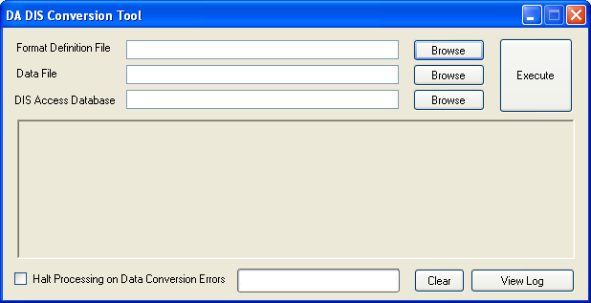**

## To Specify Files

The Format Definition File, Data File and DIS Access Database fields must be entered prior to starting the conversion process.

The Format Definition File is an XML file which contains mapping information between the fields in the text Data File and the target DIS Access Database. Enter the File Path and the File Name in the Format Definition File field. The Browse button is used to navigate to the Format Definition File to be used for the conversion.

The Data File is a text file which refers to the source data file. Enter the File Path and the File Name in the Data File field. The Browse button is used to navigate to the Data File to be used.

The DIS Access Database refers to the target database used by the application. It must conform to the specifications of DIS. Enter the File Path and the File Name in the DIS Access Database Definition File field. The Browse button is used to navigate to the DIS Access Database File to be used for the conversion.

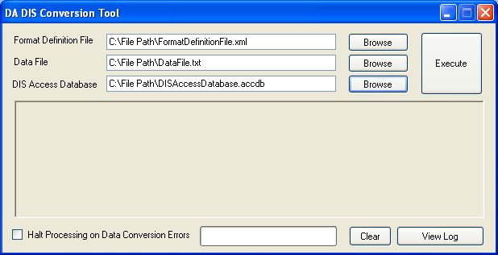

## To Halt Processing

Select the ‘Halt Processing on Data Conversion Errors’ check box to halt a process when data conversion errors are encountered by the application. Halting the process allows the user to correct the data prior to continuing with the conversion. NULL values will be inserted for data fields which fail to convert to the required data type in the target database when the Halt Processing on Data Conversion Error checkbox is not selected.

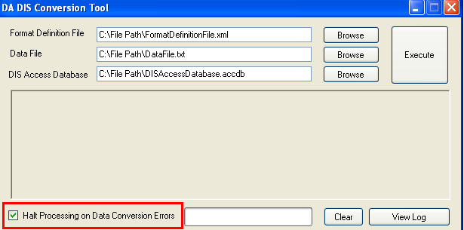

## To Execute the DIS Conversion Tool

The Execute button is used to start the conversion process. All required fields must be entered or populated before the conversion will start. The Format Definition File, Data File and Dis Access Database fields are the required fields. The Execute button is renamed to "Stop Processing" after the button is selected.



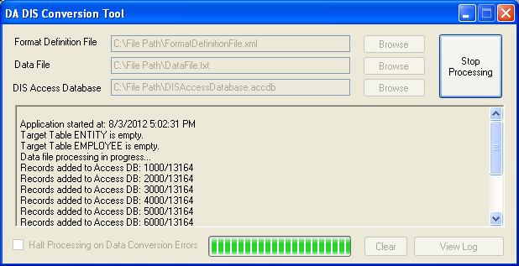

The Process window informs the user about the current tasks being performed by the application and the process completion status. With each 1000 records updated, the Progress Log window is updated with the records added. It shows the ratio of the number of records added to the total number of records.

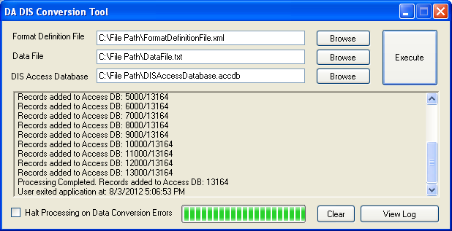

On successful completion of the execution process, data is transferred to the target Access file. Error Messages will display in the Process window and in the Error Log when the conversion process does not complete successfully. Unsuccessful data will not be transferred to the Access database file.

### To Clear Tables

The Clear Target Tables window displays after the Execute button is selected and the conversion process starts. The DIS Access Database is used to convert the data. This database is cleared during each conversion. The Yes button is selected to have the application clear the tables and continue with the conversion process. The No button is selected to halt the conversion process and allow the user to verify the data prior to the tables being cleared. A backup of the database may also be created at this time. When the ‘No’ button is selected, the conversion process must be restarted.

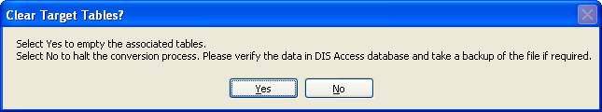

The user may choose to select the ‘No’ button to halt the conversion when the DISAccessDatabase.accdb contains data. This allows the user to review the data and take a back-up of the database prior to the conversion. The window below will display when the conversion is halted.

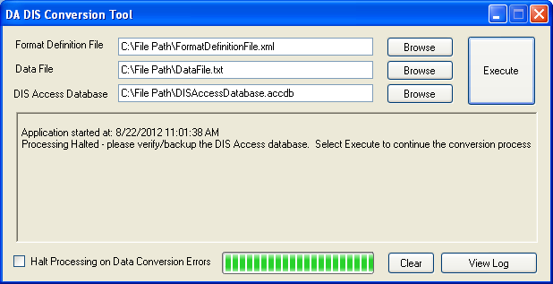

Selecting the ‘Yes’ button on the Clear Tables window begins the processing of the application. When the Access database contains data, it will be cleared. Otherwise, a message on the Process window and in the Process Log will indicate the Target table is empty.



## To Clear the Process Log

Once the execution process is completed, the ‘Clear’ button is enabled. Select the ‘Clear’ button to clear the log from the Process window. Once the Process window is cleared, the user must select the ‘View Log’ button to view the details of the Process Log.

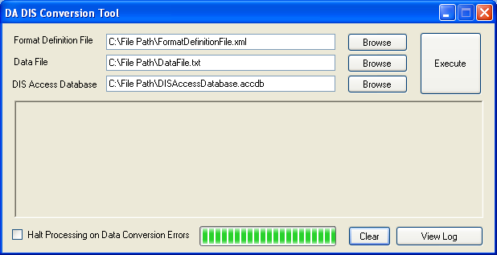

## To View the Process Log

A DISConversion Tool Process Log is created for every conversion. The details of the Process Log can be viewed on the Conversion Tool window or by selecting the View Log button. The Process Log can also be viewed by opening the DISConversion\_Log.txt file in the <install directory>.

## To Stop Processing on a Current Conversion

Encountered exceptions will display on the window informing the user to correct the source of error.

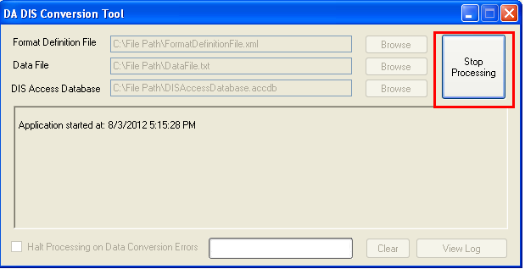

The conversion can be stopped at any point during the process by selecting the Stop Processing button. Stopping the process allows the user to correct the data related to the encountered errors displayed on the Process window. The conversion is restarted by selecting the Execute button.

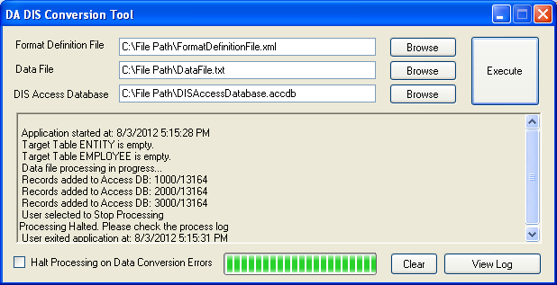

## To Exit the Application

The DIS Conversion Tool is closed by selecting the red X in the upper right hand corner of the tool. Select "Yes" on the Exit window to continue exiting the application. Select "No" on the Exit window to keep the application open.

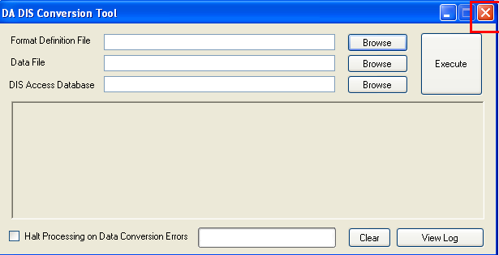



# Working with the Command Line

The Working with the Command Line application section explains in detail how the tool is used to work with Command line functionality.

## To Open the Command Prompt

Navigate to the Command Prompt. Windows button Start => All Programs =>Accessories => Command Prompt.

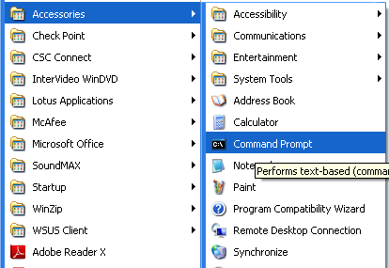

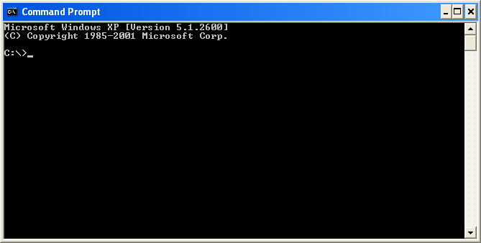

## Command Line Arguments

The Command Line for running the DIS Conversion Tool requires five arguments. Each argument must be enclosed in double quotes. A space must separate each argument.

The First argument is the DIS Conversion Tool exe. The file path and the name of the file must be entered as part of the argument. Navigate to the path where the application is installed.   
Example: “C:\Program Files\DIS CONVERSION TOOL\ DIS Conversion Tool.exe”

The Second Argument is the Format Definition File. This is an XML file which contains mapping information between the fields in the text Data File and the target DIS Access Database. The file path and the name of the file must be entered as part of the argument.  
Example: “C:\File Path\ FormatDefinitionFile.xml”

The Third Argument is the Data File. This text file refers to the source data file. The file path and the name of the file must be entered as part of the argument.  
Example: “C:\File Path\ DataFile.txt”

The Fourth Argument is the DIS Access Database File. This Access database refers to the target database used by the application. It must conform to the specifications of DIS. The file path and the name of the file must be entered as part of the argument.  
Example: “C:\File Path\ DISAccessDatabase.accdb”

The Fifth Argument is the Clear Table option. Enter ‘Yes’ if clearing of table is required. Enter ‘No’, incase back-up of target DIS Access database is required. By selecting ‘No’, data conversion process is halted. The conversion must be restarted after it has been halted.

## To Execute the DIS Conversion Tool using the Command Line

Enter the arguments in the Command Line in the order as stated in the Command Line Arguments section. Each argument must be enclosed in double quotes. A space must separate each argument.

Once the arguments are provided, select the Enter key to start the conversion. The Command Line application runs in silent mode. The DIS Conversion Tool will not be visible.

In this Example, the Fifth argument is passed as ‘Yes’. The conversion will clear the data present in the Access database. If the DIS Access Database provided is empty, a message is written to the Process Log indicating the ‘Target Table is Empty’. When data is present in DIS Access Database, it will be cleared without any warning.

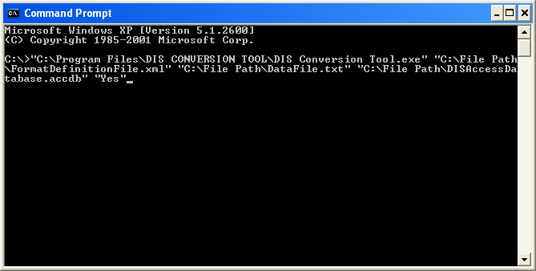

When ‘No’ is passed as the Fifth Argument, the Process will halt and a message is written to the Process Log to verify the Access Database and take a backup.

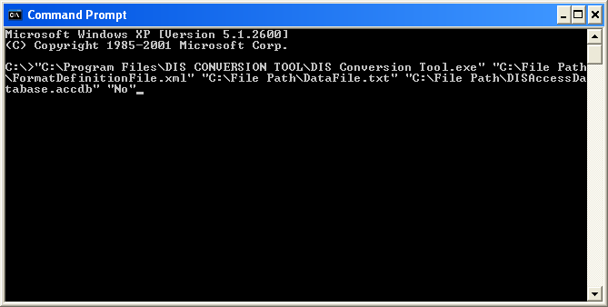

Once the process is completed, the Process Log is generated in the same file directory the DIS Conversion Tool.exe. The Process Log file lists the processes executed. All errors messages and invalid arguments will also be listed in the Process Log. All valid data will be updated in the target Access database.